**Electric Pencil**

Electric Pencil家用电脑第一个字处理软件。作为第一个文字处理程序，Electric Pencil，开发者是美国人[迈克尔·思瑞尔](http://www.techcn.com.cn/index.php?doc-innerlink-%E8%BF%88%E5%85%8B%E5%B0%94%C2%B7%E6%80%9D%E7%91%9E%E5%B0%94)（[Michael Shrayer](http://www.techcn.com.cn/index.php?doc-innerlink-Michael%20Shrayer)）。Michael Shrayer完成了Electric Pencil的开发，这是早期流行的、用于微计算机的文字处理软件。

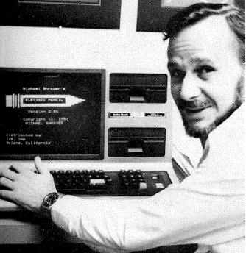

但是历史上没有WordStar、微软Word那样能够持续辉煌。WordStar的同类软件中，早期的Electric Pencil以及稍晚的Word都很优秀，甚至WordPerfect也应当占有一席之地。但相比之下WordStar占据这一位置更是众望所归，因为正是它带来了文字处理领域的革命，自上世纪70年代末发布以后垄断市场将近10年。如果没有WordStar，人类进行文字处理的方式也许和现在截然不同。

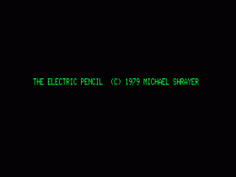

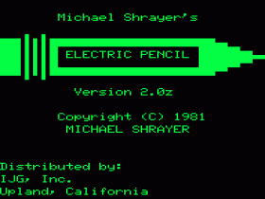

目录

• [字处理软件之父简介](http://www.techcn.com.cn/index.php?doc-view-140965.html#1)

• [Electric Pencil](http://www.techcn.com.cn/index.php?doc-view-140965.html#3)

• [历史上最佳的25款软件](http://www.techcn.com.cn/index.php?doc-view-140965.html#5)

• [WordStar(1978年-1979年)](http://www.techcn.com.cn/index.php?doc-view-140965.html#7)

* • [Word 1.0，一个传奇的诞生](http://www.techcn.com.cn/index.php?doc-view-140965.html#9)
* • [参考文献](http://www.techcn.com.cn/index.php?doc-view-140965.html#11)

字处理软件之父简介[回目录](http://www.techcn.com.cn/index.php?doc-view-140965.html" \l "section)

Electric Pencil, released in 1976, was the first word processor for home computers.

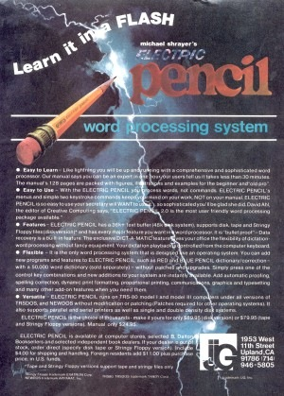

It was developed by a programmer named Michael Shrayer who apparently wanted to document his own software on the same machines he was programming.

Versions were created for the Altair 8800, the Processor Technology Sol-20, the NorthStar Horizon, TRS-80, and IBM PC among other machines. It was ultimately eclipsed by Micropro International's WordStar.

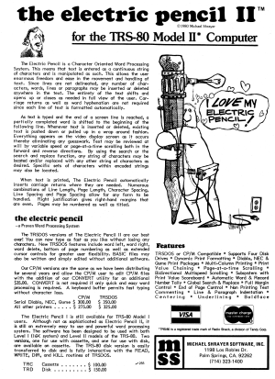

Most releases of Electric Pencil worked only with video cards which offered 16 lines of 64 characters such as the Processor Technology VDM-1. Those video cards mapped their 1024 on-screen characters to 1024 bytes of memory at address 0CC00H. Electric Pencil directly manipulated this memory.

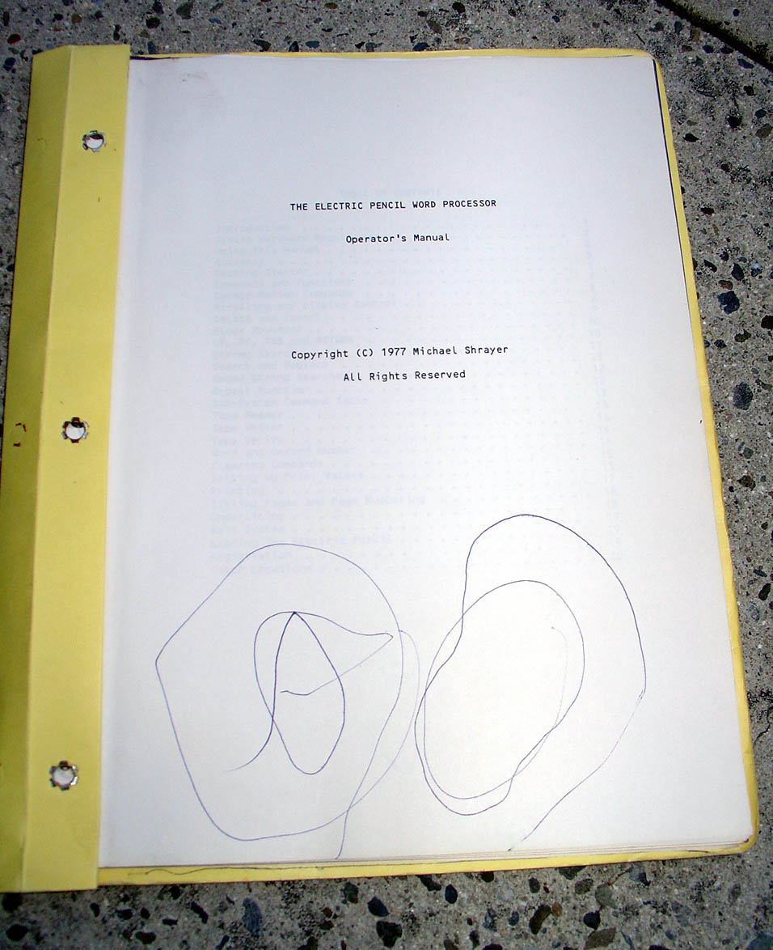

Electric Pencil was written in 8080 assembly language and could also run on Zilog Z-80 computers.

Electric Pencil[回目录](http://www.techcn.com.cn/index.php?doc-view-140965.html" \l "section)

Electric Pencil (also known as The Electric Pencil) was the first word processor written for a microcomputer. The original version was created by Michael Shrayer and released for the MITS Altair in December 1976. The TRS-80 version was released almost two years later and it dominated the market until the introduction of Scripsit.

Electric Pencil was one of only five pieces of software inducted into the *80 Micro* Hall of Fame in 1983, with the panel stating that Electric Pencil “demonstrated conclusively that a TRS-80 could be used for serious word processing, and was the model for later word processors.”



Michael Shrayer Software advertisement   
from the July 1980 issue   
of [*80 Microcomputing*](http://www.trs-80.org/80_microcomputing/)

Origins

Michael Shrayer purchased an MITS Altair computer kit after seeing the January 1975 issue of the *Popular Electronics*. He later expanded his Altair with a paper punch, video display, and keyboard and he began writing machine language programs.

What became known as Electric Pencil started when Shrayer made some improvements to an editor assembler package called Software Package 1 or SP-1. He named his improved version Extended Software Package 1 or ESP-1. Shrayer decided he didn’t want to use a typewriter to write the documentation for ESP-1 but to use his Altair instead. There were no suitable programs available, so he decided to write his own. As he stated in an 1984 article in *Creative Computing*:

I developed the original Electric Pencil to document something called ESP-1. At that time, I didn’t even know that a product like Pencil was called a word processor. In fact, Electric Pencil was the first word processor ever written for a microcomputer. I used Pencil to document ESP-1 and then itself.

The new Electric Pencil program was unlike anything else available, and there was great demand for the program. Shrayer began selling it through his company, Michael Shrayer Software, Inc. Peoples wanted versions for computers other than the Altair, and 78 different versions were created for different computers and operating systems by 1980.

The popularity of Electric Pencil made it an early target for software pirates. By one estimate, ten copies were pirated for every legitimate copy sold.

Electric Pencil for the TRS-80



Electric Pencil title screen

Electric Pencil was adapted in 1978 to the TRS-80 Model I by Small System Software. The price was $150.00 for the disk version and $99.95 for the cassette version (with both Level I and Level II versions on the same tape). It was enormously successful, becoming the dominant TRS-80 word processor.

The Electric Pencil advertisements promised a number of features:

Write text, delete, insert, or move words, lines, paragraphs, save text on tape (or disk), then print formatted copy with our TRS232 or Centronics printer (RS-232C with disk version). Right justification, page titling and numbering, transparent cursor and repeating keyboard. Upper case only, or lower case with modification.

Somewhat unusually, there were two recommended hardware modifications in the TRS-80 Electric Pencil manual. They were:

* [The Electric Pencil lower case modification](http://www.trs-80.org/electric-pencil-lowercase-modification/)
* The Electric Pencil control key

Because of the way the Electric Pencil lower case modification handled the character set, it was incompatible with Level II BASIC. That incompatibility meant that an important part of the modification was the installation of a switch on the keyboard to enable and disable it. Those switches were a very common sight at one time on Model I keyboards.

Electric Pencil II

Electric Pencil II was released in 1978, but was only available for CP/M and (later) Model II TRSDOS. It was considerably more expensive, at $325 for the Model II TRSDOS version and $275 for the CP/M version. Version I (as the original Electric Pencil was now named) remained available for other computers.



IJG advertisement from the   
September 1982 issue of [*80 Micro*](http://www.trs-80.org/80-microcomputing/)

Electric Pencil 2.0

In January 1981, IJG Computer Services, Harvard Pennington’s company, took over distribution of Electric Pencil from Michael Shrayer Software. IJG released a new version of Electric Pencil in February 1982. The new version 2.0 (no relation to Electric Pencil II) was not a set of patches but was assembled from the original source code. Additions by Richard Schubert fixed many bugs and added new features. The price for Electric Pencil was lowered to $89.95 for the disk version and $79.95 for tape or [Exatron Stringy Floppy](http://www.trs-80.org/exatron-stringy-floppy/) version. (Electric Pencil was one of the few programs to have a native Stringy Floppy version.)

IJG also introduced two add-ons to Electric Pencil:

* Blue Pencil, a “dictionary-proofing program” (spell-checker) with a 50,000 word dictionary for $89.95
* Red Pencil, an “automatic spelling correction” program for $89.95 which required Blue Pencil to operate

Another new product released by IJG was an IBM PC version of Electric Pencil, written by Dale Buscaino and Scott Daniel of Progressive Software Design. IJG sold that product to Electric Software Corporation in 1986, which continued to advertise it for several years.

Legacy



Electric Pencil 2.0 title screen

The original version of Electric Pencil had a powerful impact, influencing almost all word processors that followed it. I think that this quote from the original manual best exemplifies the attitude behind Electric Pencil that helped make it so successful:

Knowing full well that instruction manuals can be rather tedious, this one was assembled with ease of application as its main criteria. This text is not intended to be a course but rather a guide to the proper operation of The Electric Pencil Word Processing System. Within a few hours, anyone can certainly start using The Electric Pencil and in less than a few days can be expert at it. It is assumed that the reader is familiar with a standard electric typewriter keyboard.

THE BEST WAY TO LEARN TO OPERATE THIS SYSTEM IS TO USE IT!!!

Trying all the commands and experimenting with different combinations as well as discovering the most efficient ways to do things will really pay off.

历史上最佳的25款软件[回目录](http://www.techcn.com.cn/index.php?doc-view-140965.html" \l "section)

eWeek总结了过去几十年里的最佳的25款软件。  
　　1976: [Electric Pencil](http://www.techcn.com.cn/index.php?doc-innerlink-Electric%20Pencil)  
　　1978: [WordStar](http://www.techcn.com.cn/index.php?doc-innerlink-WordStar)  
　　1979: [VisiCalc](http://www.techcn.com.cn/index.php?doc-innerlink-VisiCalc)

　　1981: [dBase II](http://www.techcn.com.cn/index.php?doc-innerlink-dBase%20II)  
　　1982: [AutoCAD](http://www.techcn.com.cn/index.php?doc-innerlink-AutoCAD)  
　　1983: [Lotus 1-2-3](http://www.techcn.com.cn/index.php?doc-innerlink-Lotus%201-2-3)  
　　1983: [Turbo Pascal](http://www.techcn.com.cn/index.php?doc-innerlink-Turbo%20Pascal)  
　　1984: [MacWrite/MacPaint](http://www.techcn.com.cn/index.php?doc-innerlink-MacWrite/MacPaint)  
　　1984: [MultiMate](http://www.techcn.com.cn/index.php?doc-innerlink-MultiMate)  
　　1985: [Excel for Macintosh](http://www.techcn.com.cn/index.php?doc-innerlink-Excel%20for%20Macintosh)  
　　1985: [Aldus PageMaker](http://www.techcn.com.cn/index.php?doc-innerlink-Aldus%20PageMaker)  
　　1986: [Cross-network E-mail](http://www.techcn.com.cn/index.php?doc-innerlink-Cross-network%20E-mail)  
　　1987: [Excel for Windows](http://www.techcn.com.cn/index.php?doc-innerlink-Excel%20for%20Windows)  
　　1987: [dBase Mac](http://www.techcn.com.cn/index.php?doc-innerlink-dBase%20Mac)  
　　1988: [Mathematica 1.0](http://www.techcn.com.cn/index.php?doc-innerlink-Mathematica%201.0)  
　　1989: [Word for Windows](http://www.techcn.com.cn/index.php?doc-innerlink-Word%20for%20Windows)  
　　1990: [Windows 3.0](http://www.techcn.com.cn/index.php?doc-innerlink-Windows%203.0)  
　　1990: [Adobe Photoshop](http://www.techcn.com.cn/index.php?doc-innerlink-Adobe%20Photoshop)  
　　1991: [Microsoft Visual Basic](http://www.techcn.com.cn/index.php?doc-innerlink-Microsoft%20Visual%20Basic)  
　　1994: [Netscape Navigator 1.0](http://www.techcn.com.cn/index.php?doc-innerlink-Netscape%20Navigator%201.0)  
　　1995: [Internet Explorer 1.0](http://www.techcn.com.cn/index.php?doc-innerlink-Internet%20Explorer%201.0)  
　　1996: [Palm HotSync](http://www.techcn.com.cn/index.php?doc-innerlink-Palm%20HotSync)  
　　2001: [Mac OS X](http://www.techcn.com.cn/index.php?doc-innerlink-Mac%20OS%20X)  
　　2001: [Apple iTunes](http://www.techcn.com.cn/index.php?doc-innerlink-Apple%20iTunes)  
　　2004: [Mozilla Firefox 1.0](http://www.techcn.com.cn/index.php?doc-innerlink-Mozilla%20Firefox%201.0)

WordStar(1978年-1979年)[回目录](http://www.techcn.com.cn/index.php?doc-view-140965.html" \l "section)

WordStar与其前辈“Electric Pencil”和后裔“Microsoft Word”等都是一流的文字处理程序，但相比之下WordStar更值得一提。因为WordStar是第一款真正受欢迎的文字处理程序，垄断文字处理市场10余年之久。

Word 1.0，一个传奇的诞生[回目录](http://www.techcn.com.cn/index.php?doc-view-140965.html" \l "section)

Microsoft Word 的最新版本，Microsoft Office Word 2007，将会在本月月末的时候，与微软公司的 Microsoft Office 2007 软件套装和划时代的 Windows Vista 系统一起发布给广大零售用户和小型商业客户。

该发言人表示，现在全世界范围内有超过4亿5千万名微软 Microsoft Office 用户。

她表示，Microsoft Word 在在一个拥有超过300种不同品牌和多种不同系统平台的文本处理软件市场中成长起来的。但是，在它自身的 MS-DOS 版本之外，Microsoft Word 也是是最早一批出现在 OS/2 系统和苹果 Macintosh 电脑之上的文本处理程序。

诸如“电子画笔（Electric Pencil）”之类的早期此类程序都被 WordStar、WordPerfect 或其它品牌的后起之秀给淘汰掉了，但是 Word 是一个例外，虽然它正式发布于1989年，比 WordStar 和 WordPerfect 的发布时间还要早２年。而5年过后，Word 就完全击败了自己的其它竞争对手，占据了文本处理市场上90%的市场份额。

微软公司的一位高级主管，公司的联合副总裁 Peter Pathe ，自 Word 软件的“幼儿时期”开始，就一直养育和照顾着 Word 软件。

    他在1991年的时候加入了微软公司，最开始的时候是负责 TrueType 字体系统的研发工作，然后在1993年的时候他又被任命领导微软公司桌面应用程序部门中的“Word 商业单位（Word Business Unit）”。

    在他的卓越领导之下，该商业单位所产生的利润到1997年的时候翻了三倍，年利润超过了20亿美元，而 Microsoft Word 也成为了全世界最为流行的文本处理软件。

    而在这期间，Word 在技术方面也取得了极大的进步。在1994年的时候，Word 具有了浏览和编辑直接源自于互联网的文档的能力；到了1995年，一个单一的 Word 版本取代了原来所发布的多种独立语言的 Word 软件版本。

    于是就这样，在对 Unicode 字体设置的原生支持和独立于设备的页面排版技术的帮助之下，Word 实现了让全球各地的不同用户之间方便地分享电子邮件和文本文档的梦想。

当谈到文本处理究竟是什么，而它所扮演的角色又究竟是怎样的时候，Pathe 表示：“文本处理是一切的基础。无论何时，当一个新的计算平台出现的时候，其最先出现的应用程序之一，同时常常也是第一个出现的应用程序就是文本处理程序。”

    他表示，无论在什么时候，软件的易用性都与其他任何特定的文本处理功能同样重要，在某些情况下，甚至是更加的重要。而 Word 软件的易用性，将会和与 Excel 和其它办公应用程序之间的连贯性和兼容性一起，成为新的用户期望。个人生产性工具软件同样也需要在协作性和团队工作能力方面得到增强。在接受微软公司官方访问的时候，Pathe 表示：“ Word 中所采用的图形设计，已经成为了当今世界现代电脑应用程序软件当中最常见的图形设计。从很多方面来讲，我都认为 Word 帮助消费者们理清了自己的思想，准确地表述出了自己希望生产型工具软件究竟应当是怎样的。”

    他说：“作为苹果 Mac 电脑的早期支持者，这在很大程度上帮助我们在开发团队当中建立起了足够的敏感性。而这一敏感性将继续贯彻于 Windows 版的 Word 软件的开发过程当中。”

    当被问到在 Word 的整个成长历程当中，都有哪些里程碑式的事件和标志的时候，Pathe 为我们列举了工具条按钮、打印预览、后台拼写和语法检查功能、自动纠错与改正、通过画笔和橡皮擦来建立表格的功能，以及其它等等等等。

参考文献[回目录](http://www.techcn.com.cn/index.php?doc-view-140965.html" \l "section)

http://en.wikipedia.org/wiki/Electric_Pencil  
http://www.trs-80.org/electric-pencil/  
http://www.digibarn.com/collections/manuals/electric-pencil/index.html